Q1. Write a c program to calculate the area of a rectangle:

a) using hardcoded inputs

Ans.

#include <stdio.h>

/* height and width of a rectangle centimeter */

int width,height,area;

int main()

{

height = 7;

width = 5;

area = height * width;

printf("Area of the rectangle = %d centimeter square\n", area);

return 0;

}

D:\UIET chandigarh\Progamming for problem solving\practical\Capture 1.PNG output

b) using inputs supplied by the user

Ans.

#include <stdio.h>

/* height and width of a rectangle centimeter */

int width,height,area;

int main()

{

printf("Enter height and width : ");

scanf("%d",&height);

scanf("%d",&width);

area = height * width;

printf("Area of the rectangle = %d centimeter square\n", area);

return 0;

}

D:\UIET chandigarh\Progamming for problem solving\practical\Capture.PNG output

Q2. Calculate the area of a circle and modify the same program to calculate the volume of a cylinder

given its radius and height.?

#include<stdio.h>

//to find the area of the circle and volume of cylinder

int main()

{

    int r,h;

    float area,pie=3.141,vol;

    printf("Enter the value of radius: \n",r);

    scanf("%d",&r);

    printf("The area of circle is %f\n",area=pie*r*r);

    // volume of cylinder

    printf("Enter the value of height: \n",h);

    scanf("%d",&h);

    printf("THe volume of cylinder is %f \n",vol=pie*r*r*h);

    return 0;

}

Output:

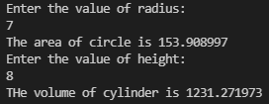

Q3. Write a program to convert Celsius (Centigrade degrees temperature to Fahrenheit)?

#include<stdio.h>

int main()

{

    float f,c;

    printf("Enter temperature in degree cecius: \n",c);

    scanf("%f",&c);

    f=c*9/5 + 32;

    printf("value of temperature in f is : %f\n ",f);

    return 0;

}

Output:



Q4. Write a program to calculate simple interest for a set of values representing principle, no of years,

and rate of interest?

#include <stdio.h>

int main()

{

    int p,time;

    float rate,interest;

    printf("Enter the value of principle: \n",p);

    scanf("%d",&p);

    printf("Enter the value rate of interest: \n",rate);

    scanf("%f",&rate);

    printf("value of time: \n", time);

    scanf("%d",&time);

    printf("The value of simple interest is : %f\n",interest=p*rate*time/100);

    return 0;

}

Output:

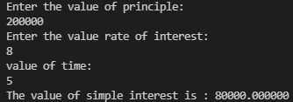

Q5. Write a program to check whether a given number is even or odd.?

#include<stdio.h>

int main()

{

    int num;

    printf("Enter an integer\n");

    scanf("%d",&num);

    if (num%2==0)

    {

        printf("the entered number is even\n");

    }

    else

    {

        printf("the no. is odd\n");

    }

    return 0;

}

Output:



Q6. Write a program to check whether the given year is leap year or not?

#include <stdio.h>

int main(){

   int y;

   printf("Enter the year to check: \n");

   scanf("%d",&y);

   if (((y % 4 == 0) && (y % 100!= 0)) || (y%400 == 0))

      printf("It is a leap year\n");

   else

      printf("It is not a leap year\n");

   return 0;

}

Output:



Q7. Write a program to find the factorial value of any number entered through the keyboard.?

#include<stdio.h>

int main()

{

    int n,fact=1;

    //here fact denotes factorial and N denotes number

    printf("Enter the number: ");

    scanf("%d",&n);

    for ( int i = 1; i <= n; i++)

    {

        fact=fact*i;

    }

    printf("Factorial of %d is: %d\n",n,fact);

    return 0;

}

Output:



Q8. Write a program to print multiplication table of a given number n.?

#include <stdio.h>

int main() {

  int n, i;

  printf("Enter an integer: ");

  scanf("%d", &n);

  for (i = 1; i <= 10; ++i) {

    printf("%d * %d = %d \n", n, i, n * i);

  }

  return 0;

}

Output:

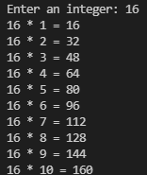

Q9. Write a program to print multiplication table of 10 in reverse order.?

#include<stdio.h>

int main()

{

  int n=1,m,a;

  printf("\nEnter the number whose table you want :");

  scanf("%d",&a);

  for(int i=10;i>=n;i--)

  {

    printf("\n%d*%d=%d",a,i,i*a);

  }

  return 0;

}

Output:

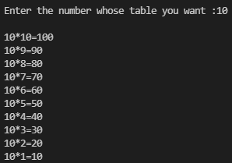

Q10. Write a program to sum first ten natural numbers using (i)while loop (ii)for loop (iii)do-while loop.?

Ans.(i)

#include <stdio.h>

int main()

{

    int n, i, sum = 0;

    printf("Enter a positive integer: ");

    scanf("%d", &n);

    for (i = 1; i <= n; ++i) {

        sum += i;

    }

    printf("Sum = %d", sum);

    return 0;

}

Ans.(ii)

#include <stdio.h>

int main()

{

    int n, i, sum = 0;

    printf("Enter a positive integer: ");

    scanf("%d", &n);

    i = 1;

    while (i <= n) {

        sum += i;

        ++i;

    }

    printf("Sum = %d", sum);

    return 0;

}

Ans.(iii)

#include <stdio.h>

int main() {

    int n, i, sum = 0;

    do {

        printf("Enter a positive integer: ");

        scanf("%d", &n);

    } while (n <= 0);

    for (i = 1; i <= n; ++i) {

        sum += i;

    }

    printf("Sum = %d\n", sum);

    return 0;

}

Output:



Q11. Write a program to calculate the factorial of a given number using (i)for loop (ii)while loop.?

Ans (ii)

#include <stdio.h>

int main()

{

int n,i,f;

f=i=1;

printf("Enter a Number to Find Factorial: ");

scanf("%d",&n);

while(i<=n)

{

f*=i;

i++;

}

printf("The Factorial of %d is : %d",n,f);

return 0;

}

Output:

Enter a Number to Find Factorial: 5

The Factorial of 5 is : 120

Ans.(i)

#include<stdio.h>

int main()

{

 int i,fact=1,number;

 printf("Enter a number: ");

  scanf("%d",&number);

    for(i=1;i<=number;i++){

      fact=fact*i;

  }

  printf("Factorial of %d is: %d",number,fact);

return 0;

}

Output:



Q12. Write a program using recursion to calculate the nth element of the Fibonacci series.?

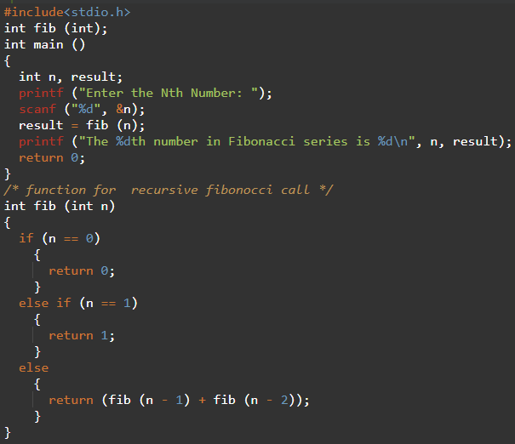

Output:



Q13. Write a recursive function to calculate the sum of first n natural numbers.?

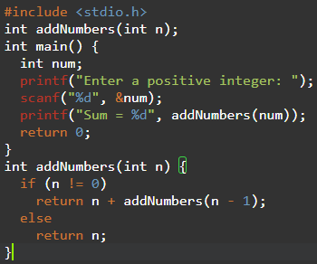

Output:



Q14. Write a program using functions to print the following pattern(first n lines):

*

* *

* * *

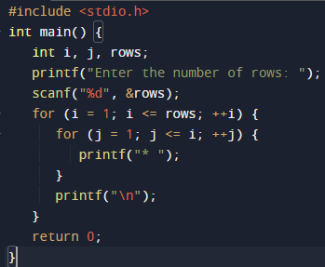

Output:

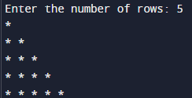

Q15 a) Write a C program to use function to insert a sub-string in to given main string from a given

position.:?

#include <stdio.h>

#include <string.h>

int main()

{

char a[10];

char b[10];

char c[10];

int p=0,r=0,i=0;

int t=0;

int x,g,s,n,o;

//clrscr();

puts("Enter First String:");

gets(a);

puts("Enter Second String:");

gets(b);

printf("Enter the position where the item has to be inserted: ");

scanf("%d",&p);

r = strlen(a);

n = strlen(b);

i=0;

// Copying the input string into another array

while(i <= r)

{

c[i]=a[i];

i++;

}

s = n+r;

o = p+n;

// Adding the sub-string

for(i=p;i<s;i++)

{

x = c[i];

        if(t<n)

        {

            a[i] = b[t];

            t=t+1;

        }

        a[o]=x;

        o=o+1;

}

printf("%s", a);

printf("\n");

return 0;

}

Output:

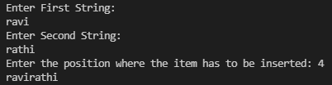

b) Write a C program to swap the values of two variables using

(i) Call by value (ii) Call by reference

#include<stdio.h>

void swap(int,int);

void main( )

{

    int n1,n2;

    printf("Enter the two numbers to be swapped\n");

    scanf("%d%d",&n1,&n2);

    printf("\nThe values of n1 and n2 in the main function before calling the swap function are n1=%d n2=%d",n1,n2);

    swap(n1,n2);

    printf("\nThe values of n1 and n2 in the main function after calling the swap function are n1=%d n2=%d",n1,n2);

}

void swap(int n1,int n2)

{

    int temp;

    temp=n1;

    n1=n2;

    n2=temp;

    printf("\nThe values of n1 and n2 in the swap function after swapping are n1=%d n2=%d\n",n1,n2);

}

Output:

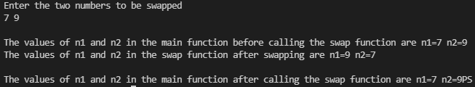

Q16. a) Write C program to find GCD of two integers by using recursive?

#include <stdio.h>

int hcf(int n1, int n2);

int main()

{

    int n1, n2;

    printf("Enter two positive integers: ");

    scanf("%d %d", &n1, &n2);

    printf("G.C.D of %d and %d is %d.\n", n1, n2, hcf(n1, n2));

    return 0;

}

int hcf(int n1, int n2) {

    if (n2 != 0)

        return hcf(n2, n1 % n2);

    else

        return n1;

}

Output:



b) Write C program to find GCD of two integers by using non-recursive function.?

#include<stdio.h>

#include<conio.h>

#include<math.h>

int gcdnonR(int i,int j)

{

   int rem;

   rem=i-(i/j*j);

   if(rem==0)

      return j;

   else

      gcdnonR(j,rem);

}

void main(){

   int a,b;

   printf("enter the two numbers:");

   scanf("%d%d",&a,&b);

   printf("GCD of %d",gcdnonR(a,b));

   getch();

}

Output:



Q17. a) Write a C program to find the largest and smallest number in a list of integers.

#include <stdio.h>

int main()

{

    int a[1000],i,n,min,max;

    printf("Enter size of the array : ");

    scanf("%d",&n);

    printf("Enter elements in array : ");

    for(i=0; i<n; i++)

    {

        scanf("%d",&a[i]);

    }

    min=max=a[0];

    for(i=1; i<n; i++)

    {

         if(min>a[i])

          min=a[i];

           if(max<a[i])

            max=a[i];

    }

     printf("minimum of array is : %d",min);

     printf("\nmaximum of array is : %d",max);

    return 0;

}

Output:

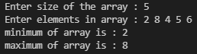

b) Write a C program to Sort the Array in an Ascending Order.?

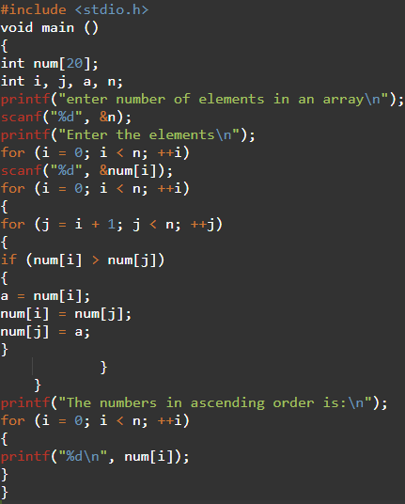

Output:

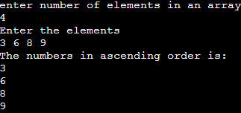

c) Write a C program to find whether the given matrix is symmetric or not.?

#include<stdio.h>

int main()

{

    int i, j, rows, columns, a[10][10], b[10][10], Count = 1;

    printf("\n Please Enter Number of rows and columns  :  ");

    scanf("%d %d", &i, &j);

    printf("\n Please Enter the Matrix Elements \n");

    for(rows = 0; rows < i; rows++)

    {

        for(columns = 0;columns < j;columns++)

        {

            scanf("%d", &a[rows][columns]);

        }

    }

    //Transpose of matrix

    for(rows = 0; rows < i; rows++)

    {

        for(columns = 0;columns < j; columns++)

        {

            b[columns][rows] = a[rows][columns];

        }

    }

    for(rows = 0; rows < i; rows++)

    {

        for(columns = 0; columns < j; columns++)

        {

            if(a[rows][columns] != b[rows][columns])

            {

                Count++;

                break;

            }

        }

    }

    if(Count == 1)

    {

        printf("\n The Matrix that you entered is a Symmetric Matrix ");

    }

    else

    {

        printf("\n The Matrix that you entered is Not a Symmetric Matrix ");

    }

    return 0;

}

Output:

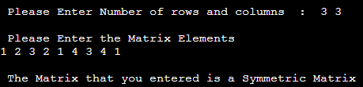

Q18. Write C program to count the number of lines, words and characters in a given text.?

#include <stdio.h>

#include <stdlib.h>

int main(){

   FILE * file;

   char path[100];

   char ch;

   int characters, words, lines;

   file=fopen("counting.txt","w");

   printf("enter the text.press cntrl Z:\n");

   while((ch = getchar())!=EOF){

      putc(ch,file);

   }

   fclose(file);

   printf("Enter source file path: ");

   scanf("%s", path);

   file = fopen(path, "r");

   if (file == NULL){

      printf("\nUnable to open file.\n");

      exit(EXIT_FAILURE);

   }

   characters = words = lines = 0;

   while ((ch = fgetc(file)) != EOF){

      characters++;

   if (ch == '\n' || ch == '\0')

      lines++;

   if (ch == ' ' || ch == '\t' || ch == '\n' || ch == '\0')

      words++;

   }

   if (characters > 0){

      words++;

      lines++;

   }

   printf("\n");

   printf("Total characters = %d\n", characters);

   printf("Total words = %d\n", words);

   printf("Total lines = %d\n", lines);

   fclose(file);

   return 0;

}